פרויקט DL

רחלי אליהו 316462324 | ספיר נחום 205651318

Epoch size: 150

Data augmentation taken:

    train_transform.transforms.append(transforms.RandomCrop(32, padding=4))

    train_transform.transforms.append(transforms.RandomHorizontalFlip())

model:

!python train.py --dataset cifar10 --data_augmentation --model resnet18 --shape triangle --length 16 --epochs 150

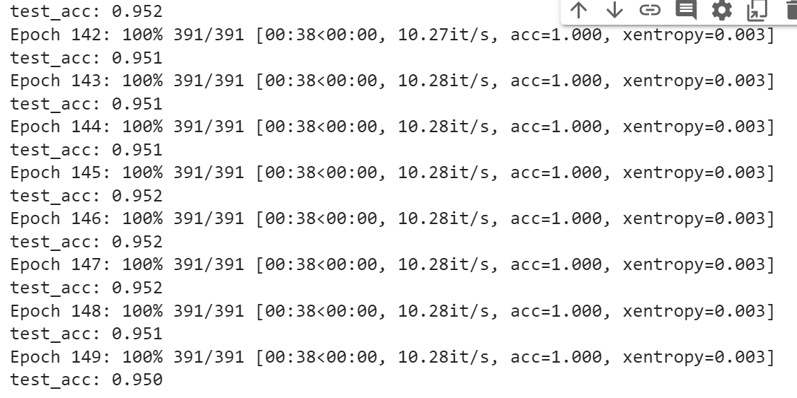

Epoch size: 150

Data augmentation taken:

    train_transform.transforms.append(transforms.RandomCrop(32, padding=4))

    train_transform.transforms.append(transforms.RandomHorizontalFlip())

model:

!python train.py --dataset cifar10 --data_augmentation --model resnet18 --cutout Cutout_Shape --shape square --length 16 --epochs 150

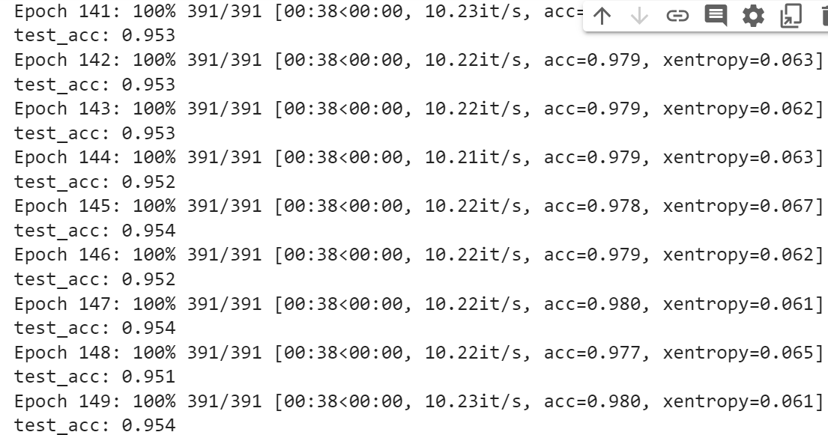

Epoch size: 150

Data augmentation taken:

    train_transform.transforms.append(transforms.RandomCrop(32, padding=4))

    train_transform.transforms.append(transforms.RandomHorizontalFlip())

Model:

!python train.py --dataset cifar10 --data_augmentation --model resnet18 --cutout Cutout_Shape --shape circle --length 16 --epochs 150

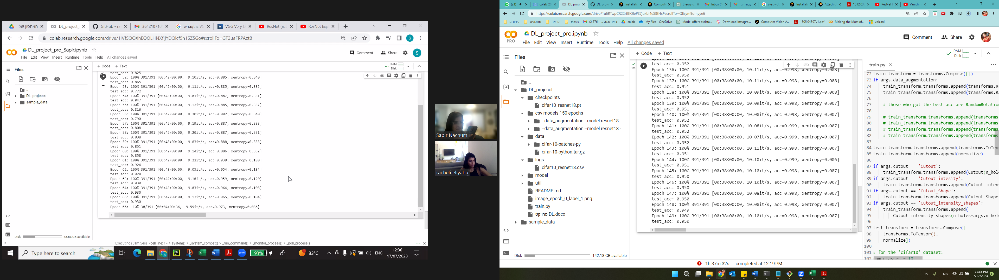

Epoch size: 150

Data augmentation taken:

    train_transform.transforms.append(transforms.RandomCrop(32, padding=4))

    train_transform.transforms.append(transforms.RandomHorizontalFlip())

Model:

!python train.py --dataset cifar10 --data_augmentation --model resnet18 --cutout Cutout_Shape --shape triangle --length 16 --epochs 150

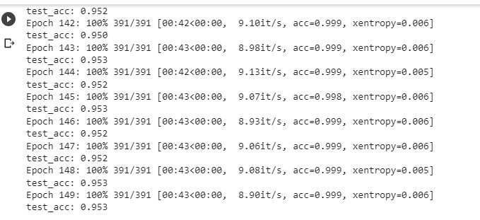

Epoch size: 150

Data augmentation taken:

    train_transform.transforms.append(transforms.RandomCrop(32, padding=4))

    train_transform.transforms.append(transforms.RandomHorizontalFlip())

Model:

!python train.py --dataset cifar10 --data_augmentation --model resnet18 --cutout Cutout_intensity_shapes --shape square --length 16 --epochs 150

Epoch size: 150

Data augmentation taken:

    train_transform.transforms.append(transforms.RandomCrop(32, padding=4))

    train_transform.transforms.append(transforms.RandomHorizontalFlip())

Model:

!python train.py --dataset cifar10 --data_augmentation --model resnet18 --cutout Cutout_intensity_shapes --shape circle --length 16 --epochs 150

Epoch size: 150

Data augmentation taken:

    train_transform.transforms.append(transforms.RandomCrop(32, padding=4))

    train_transform.transforms.append(transforms.RandomHorizontalFlip())

Model:

!python train.py --dataset cifar10 --data_augmentation --model resnet18 --cutout Cutout_intensity_shapes --shape triangle --length 16 --epochs 150

